**Develop The Web Application Using Node-RED**

|  |  |
| --- | --- |
| Team Id | PNT2022TMID41953 |
| Title | Hazardous Area Monitoring for Industrial Plant using IoT |

**Node red flow**

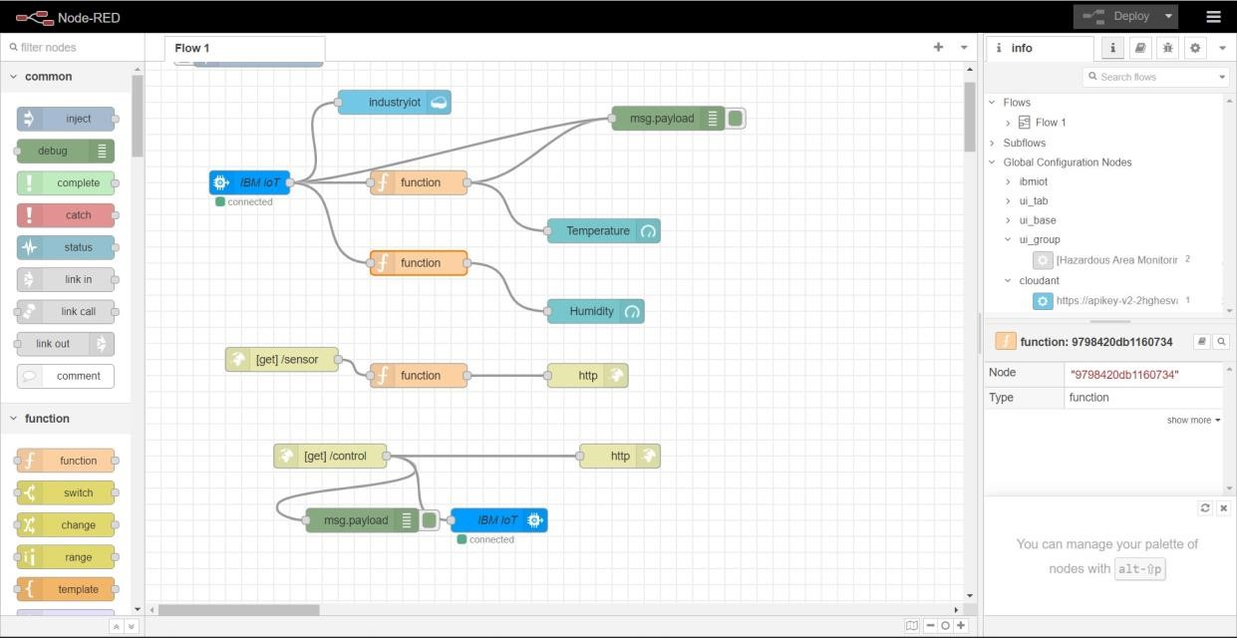

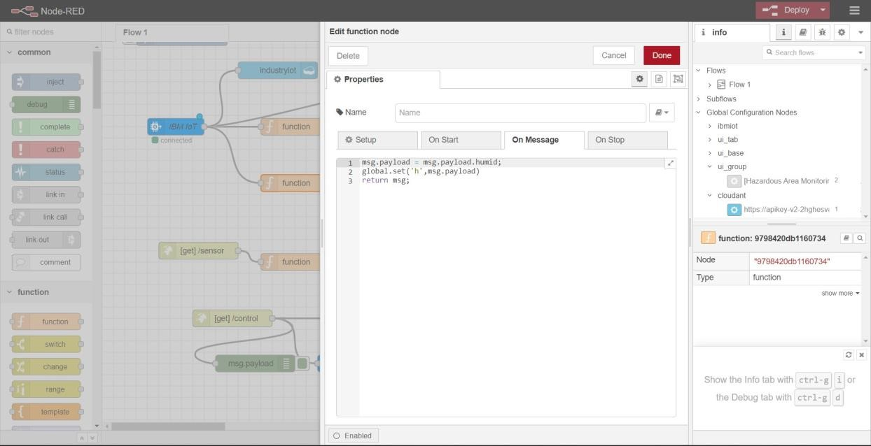**Function blocks**

